**Report**

User Name: Zirenx

Full Name: Ziren Xiao

Student ID: 675485

From the tables and graphs we can clearly see that the propagate max is better to obtain higher score, because the average score of each max depth of propagate max is higher than propagate avg. However, the cost of time of propagate max is little bit bigger. But based on much larger score, I would like to say overall, propagate max is better.

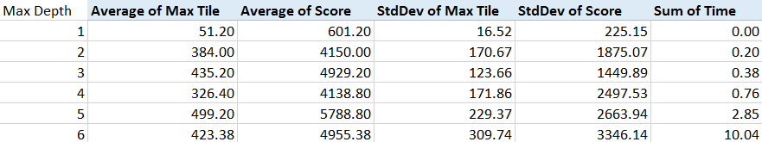

Table 1 Running Data of propagate avg 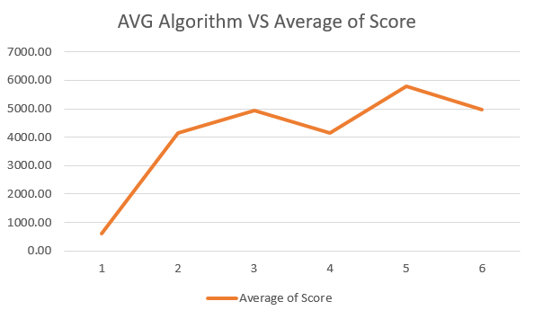

Pic 1 Line Graph of propagate avg

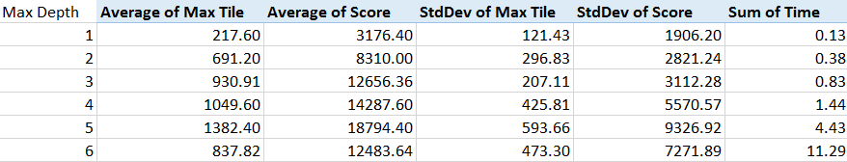

Table 2 Running Data of propagate max

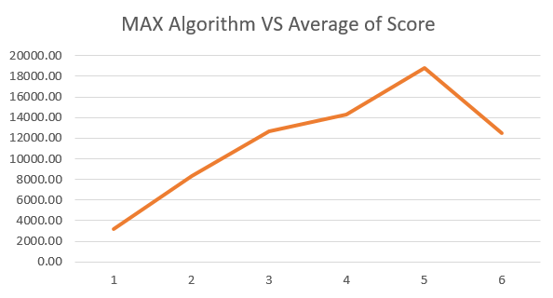

Pic 2 Line Graph of propagate max